**Load Test 1 -- Warm-up test – 10 users 5 minute duration**

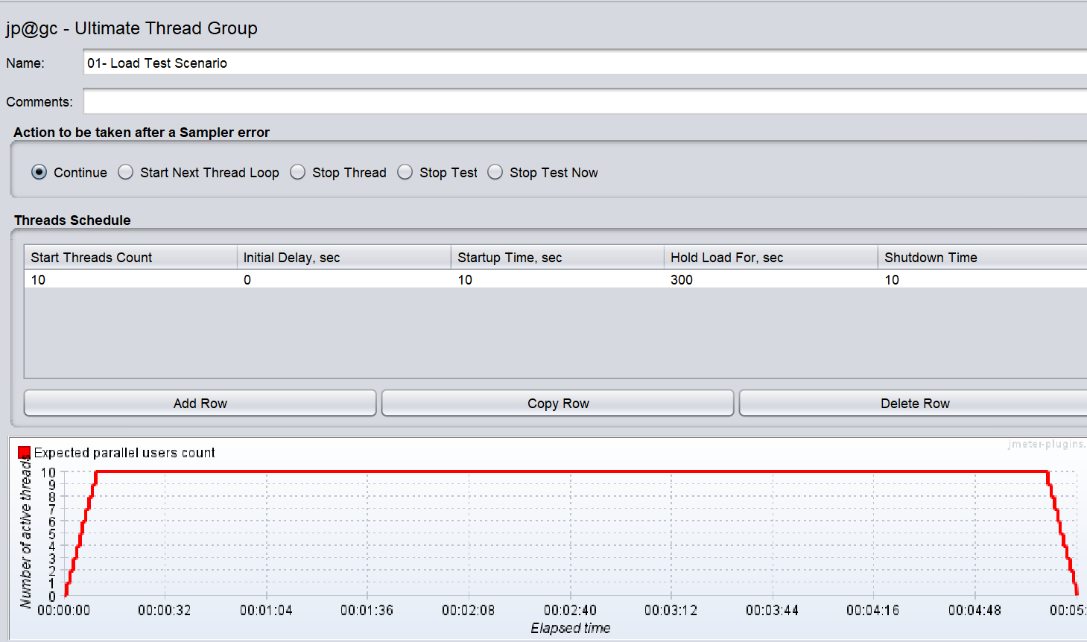

**Before execution Infra Status –**

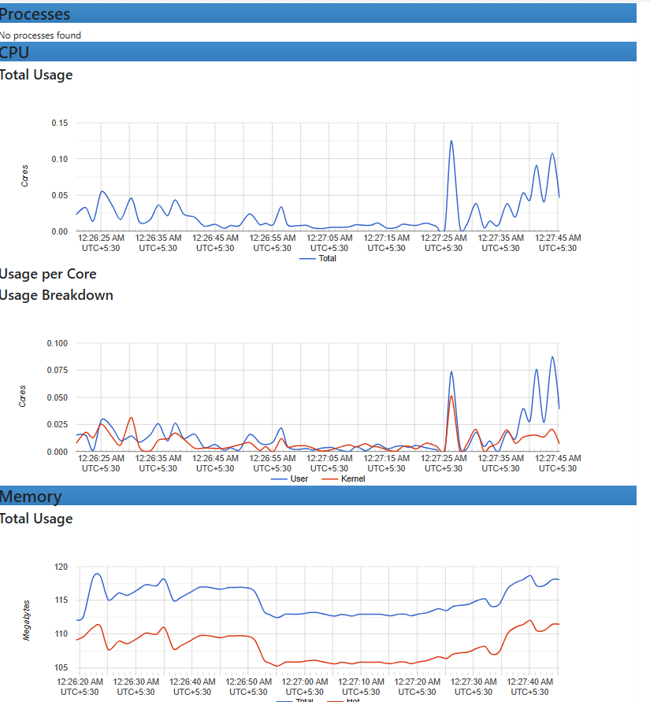

**Verify SLA during test -**

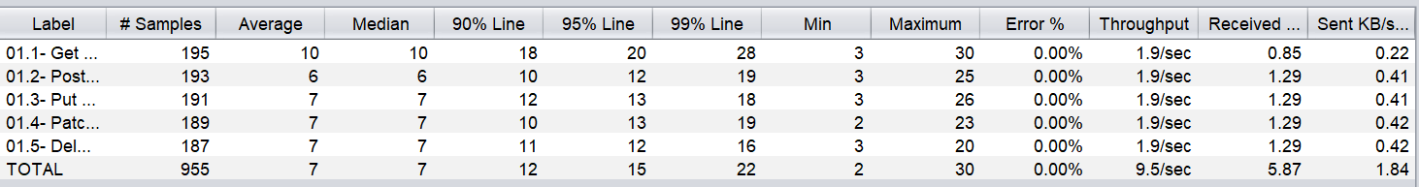

**During test Infra Status–**

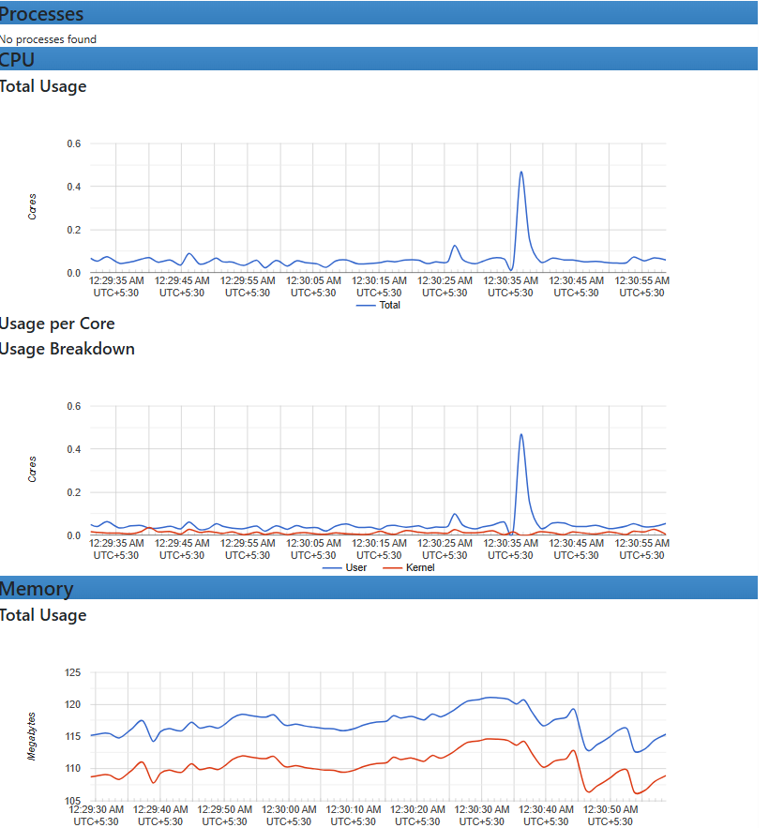

**Verify SLA after execution –**

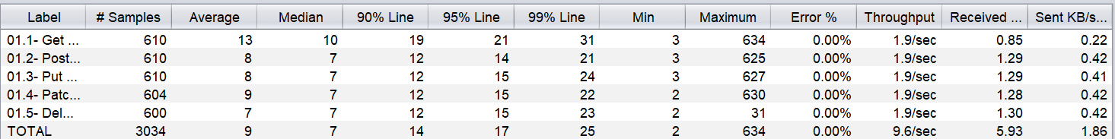

**Verify Infra Status after completing the test**

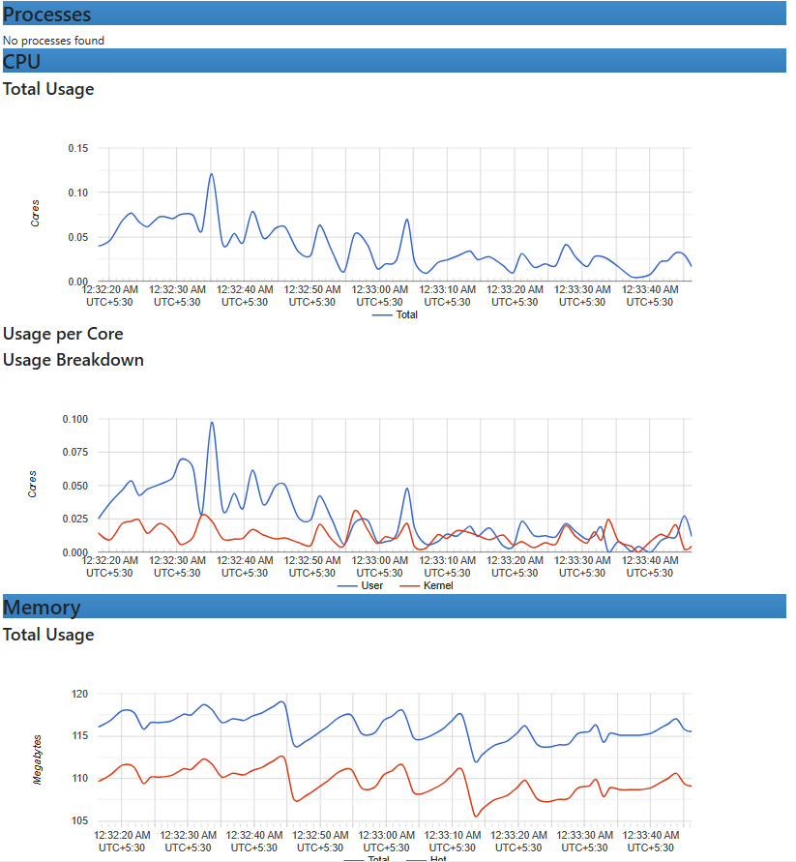

**Summary : There is no breakpoint and SLA was under control.**

**Load Test 2 -- Warm-up test – 100 users 5 minute duration**

**Configuration –**

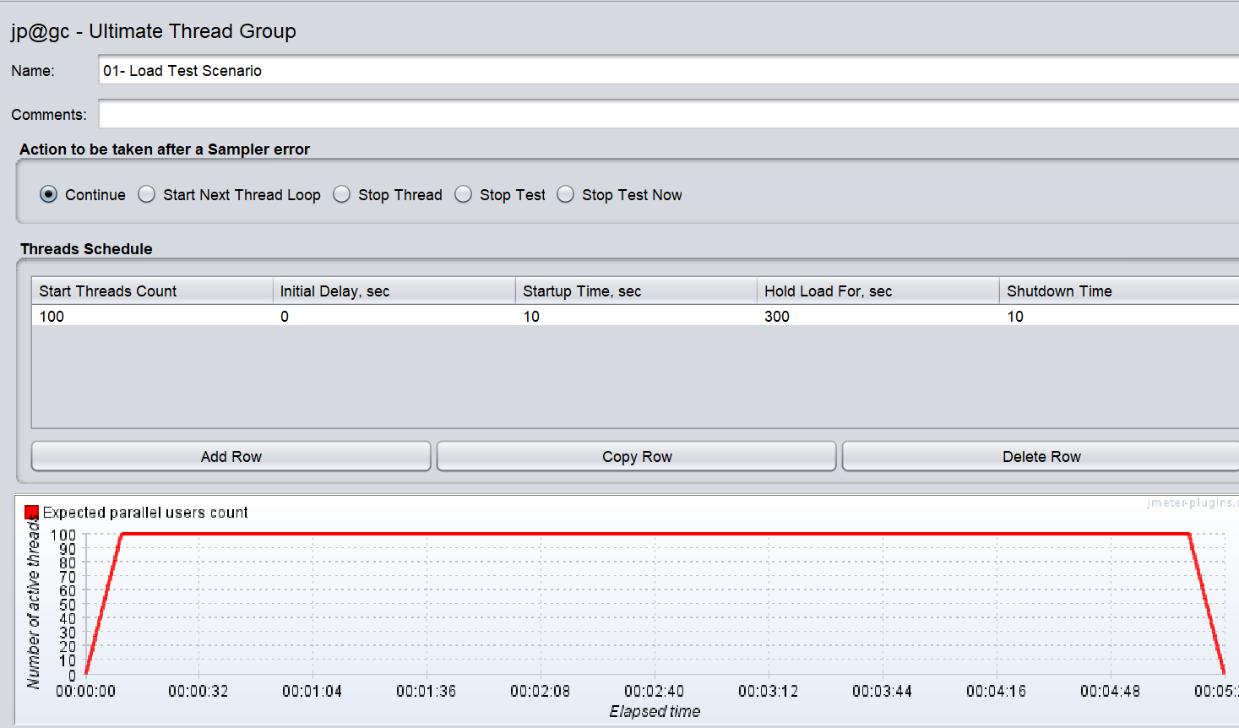

**Before execution Infra Status –**

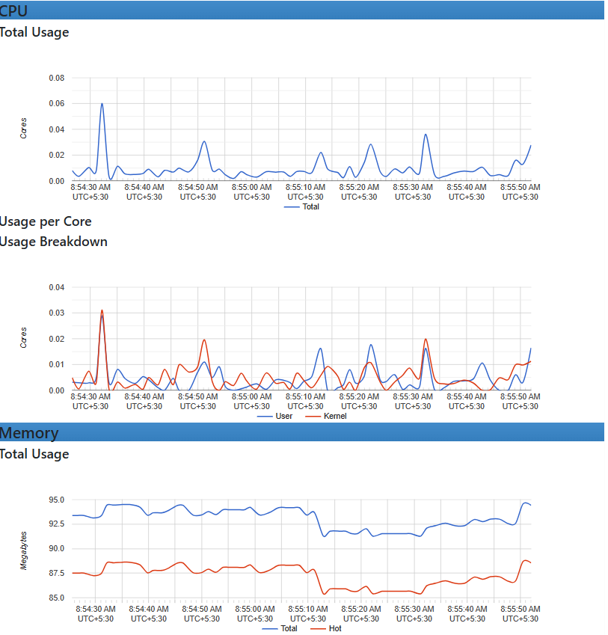

**Verify SLA during test**

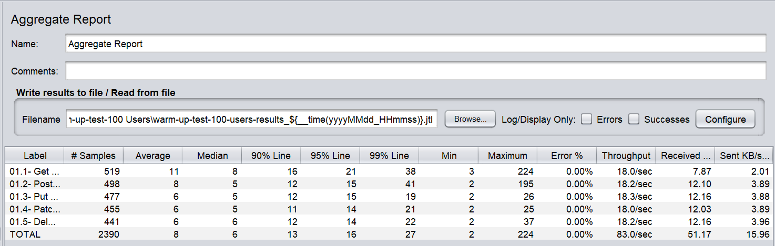

**During test Infra Status–**

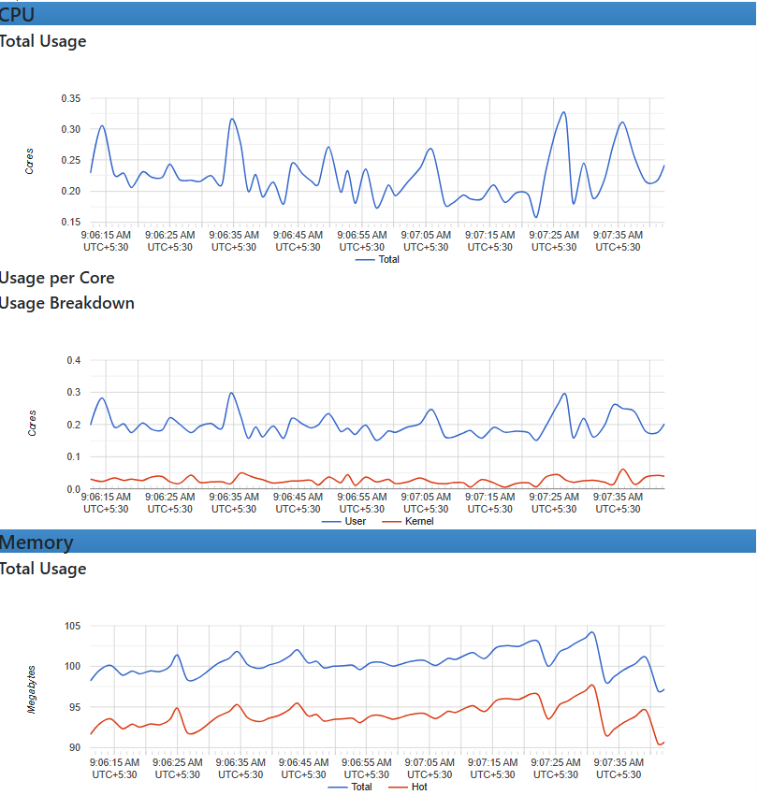

**Verify SLA after execution –**

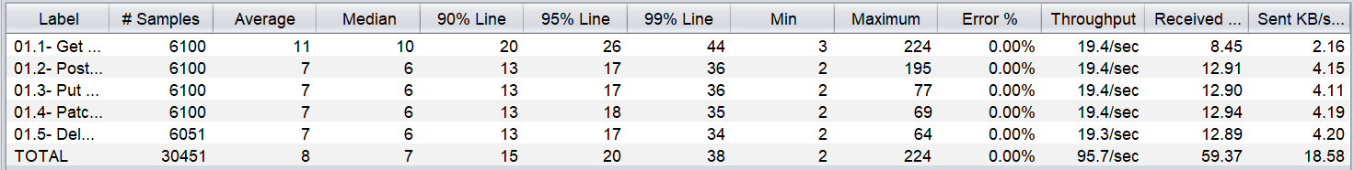

**Verify Infra Status after execution**

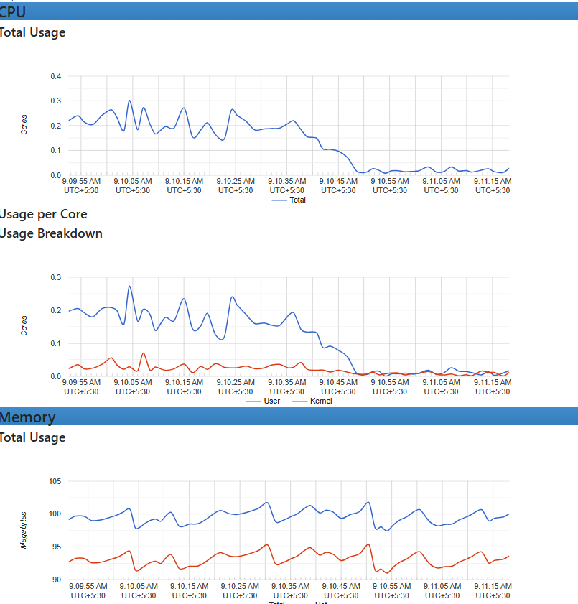

**Summary : There is no breakpoint and SLA was under control.**

**Load Test 3 -- Warm-up test – 200 users 5 minute duration**

**Configuration –**

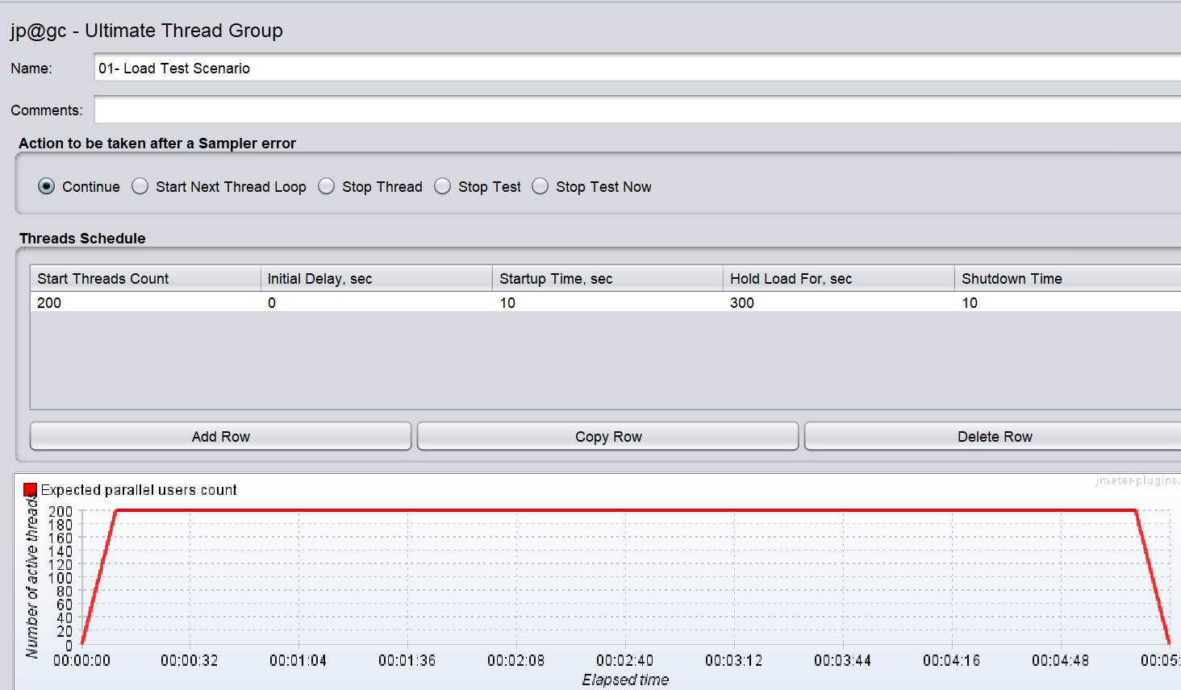

**Before execution Infra Status –**

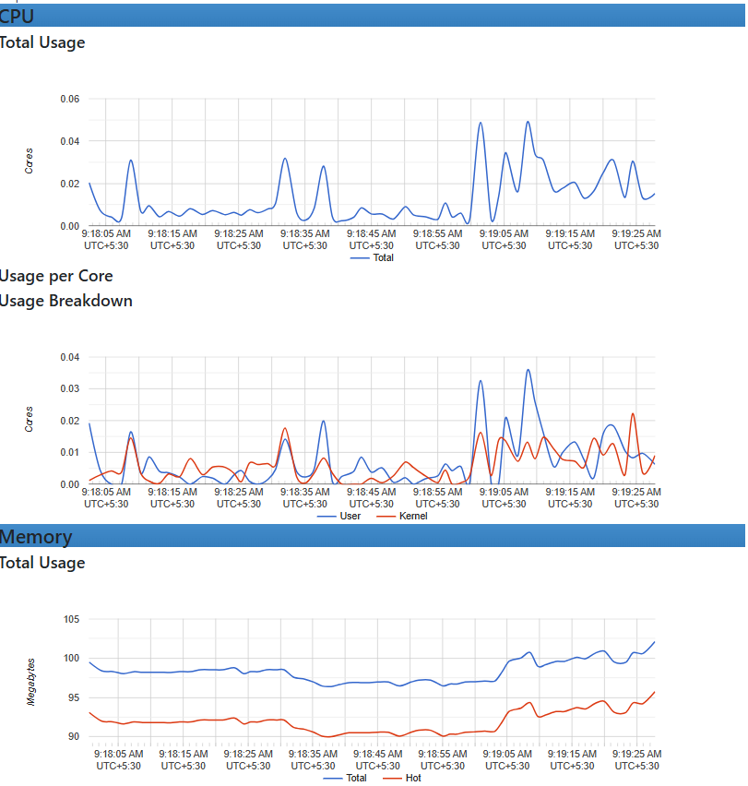

**Verify SLA during test**

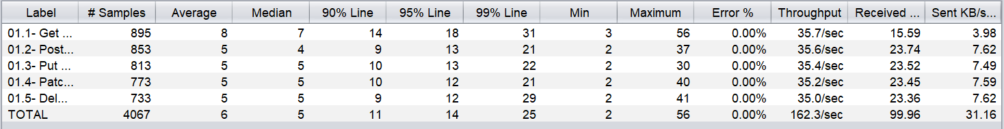

**During test Infra Status–**

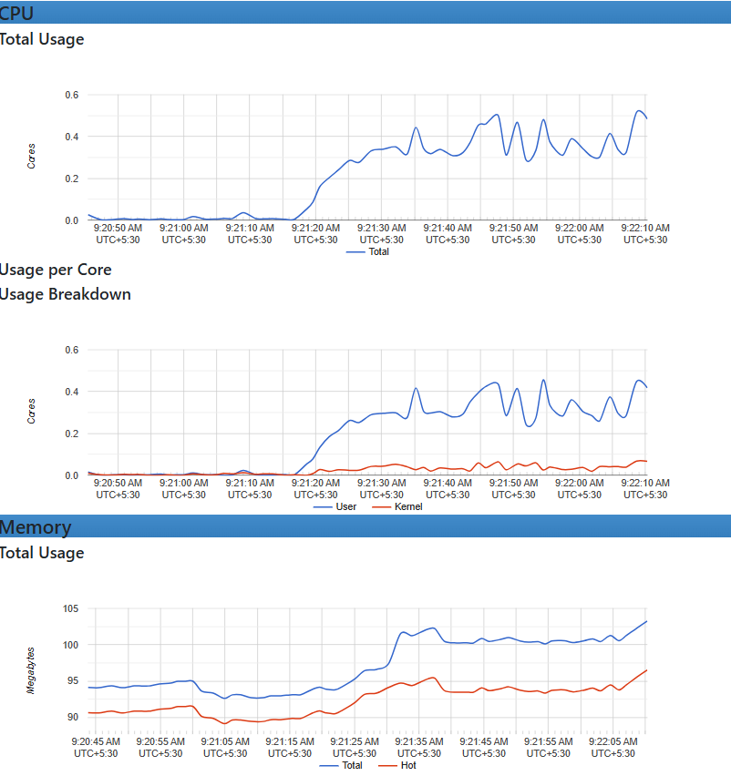

**Verify SLA after execution –**

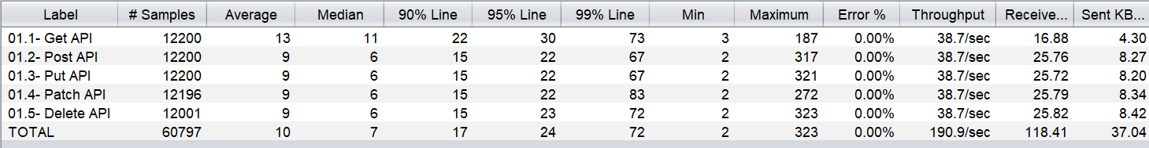

**Summary : There is no breakpoint and SLA was under control**

**Load Test 4 -- Warm-up test – 500 users 5 minute duration**

**Configuration –**

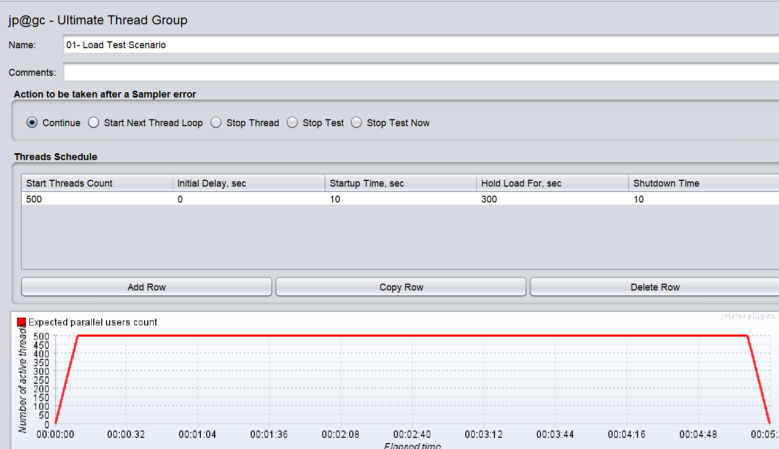

**Before execution Infra Status –**

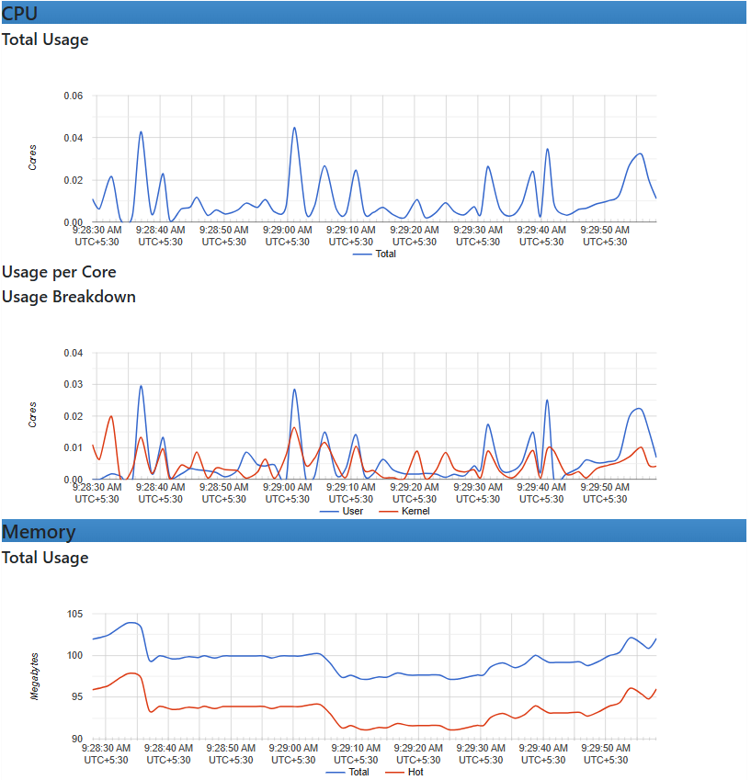

**Verify SLA during test**

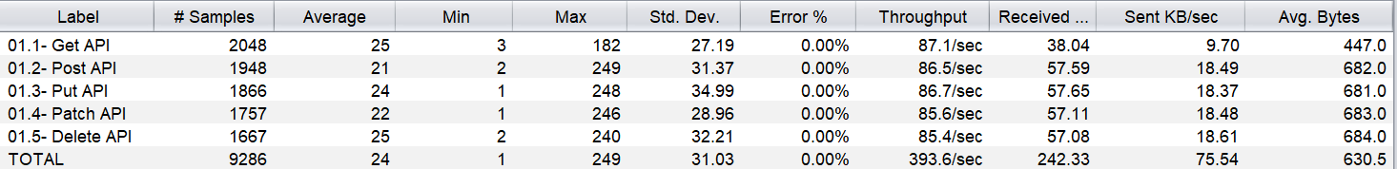

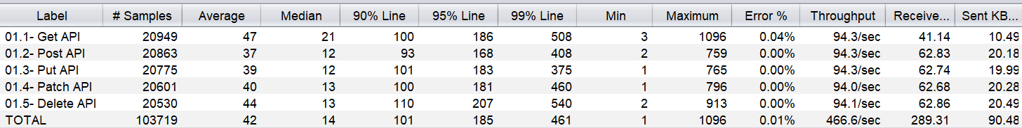

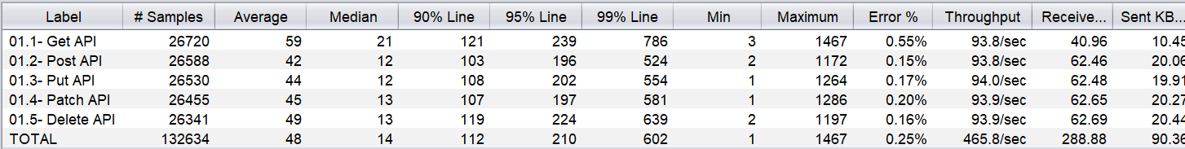

**During test Infra Status–**

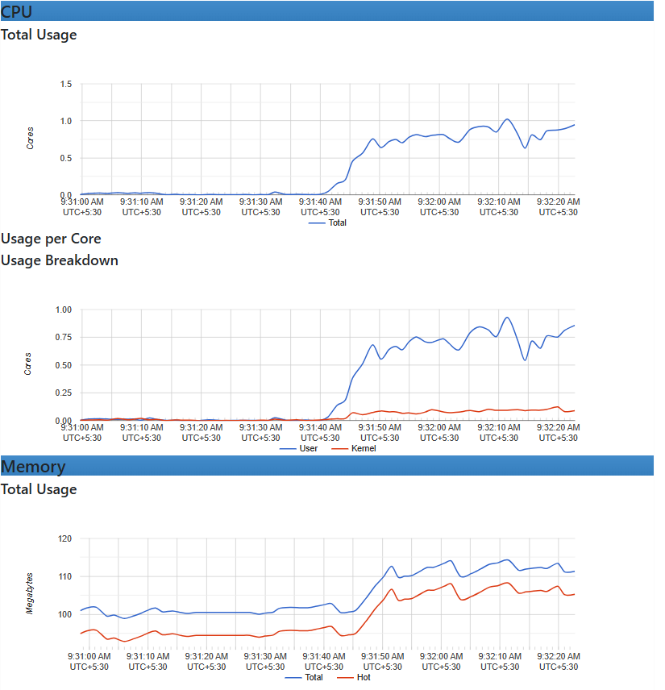

**Verify SLA after execution –**

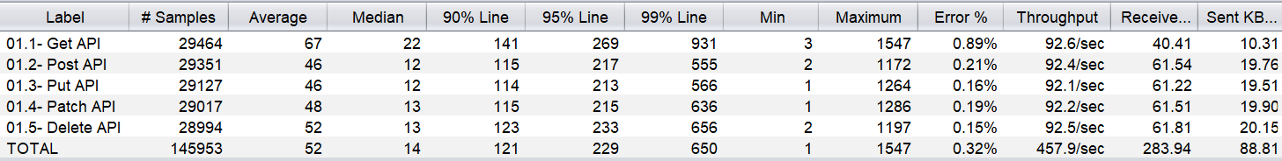

**Verify Infra Status after execution**

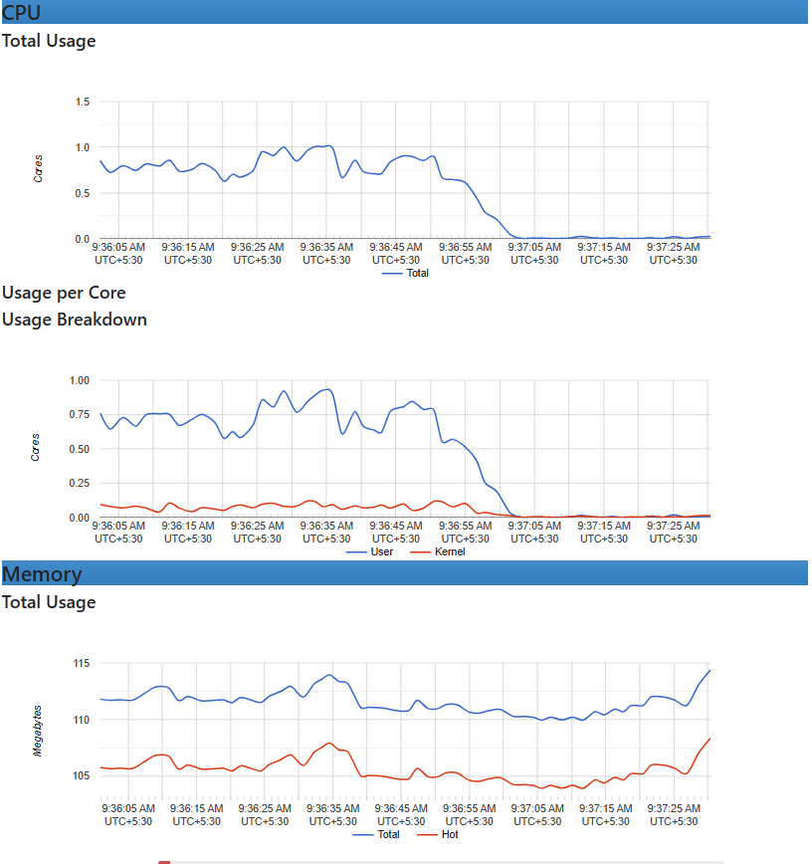

**Summary :**

1. **Response time was high and breaching our SLA**
2. **Throughput Rate also increases**
3. **Error Rate also increased.**

**Stress Test -- 700 users 10 minute duration**

**Configuration –**

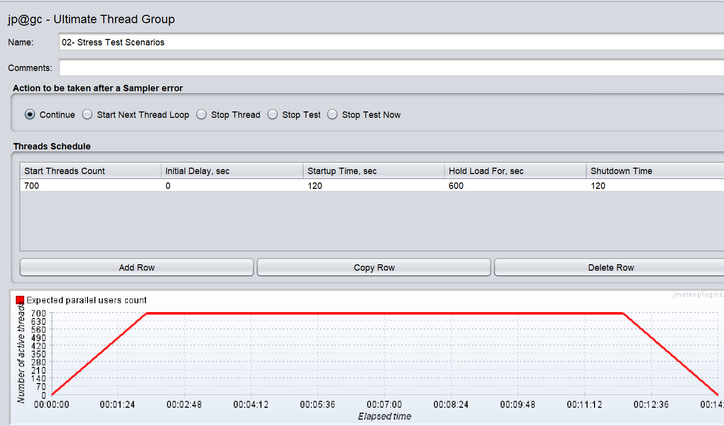

**Before execution Infra Status –**

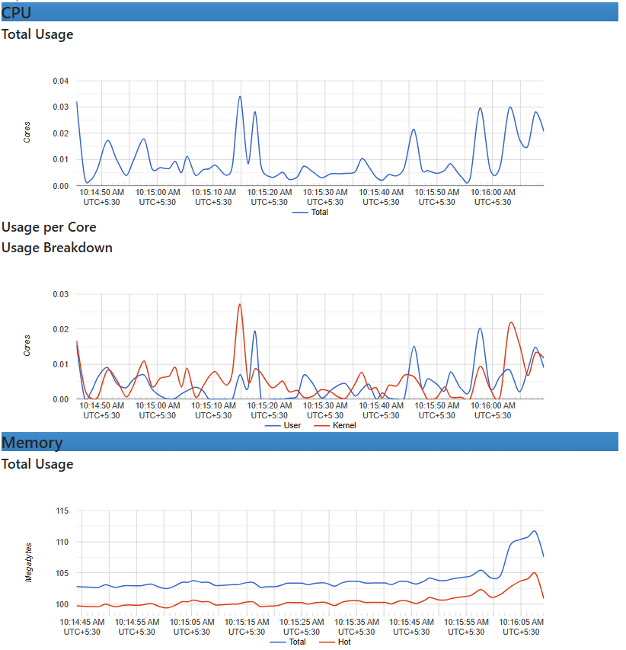

**Verify SLA during test**

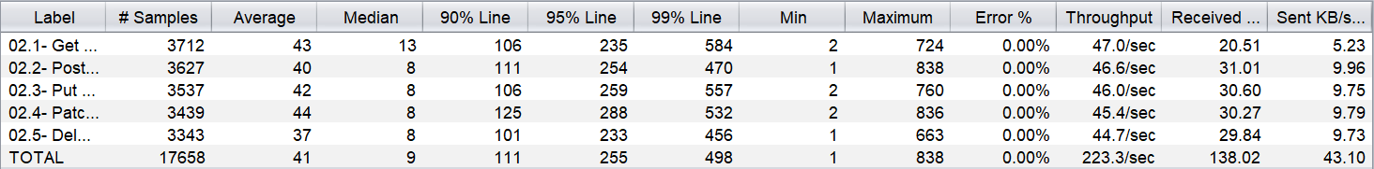

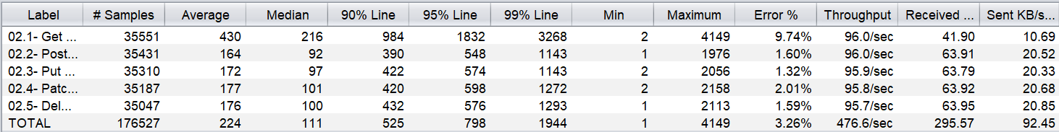

**During test Infra Status–**

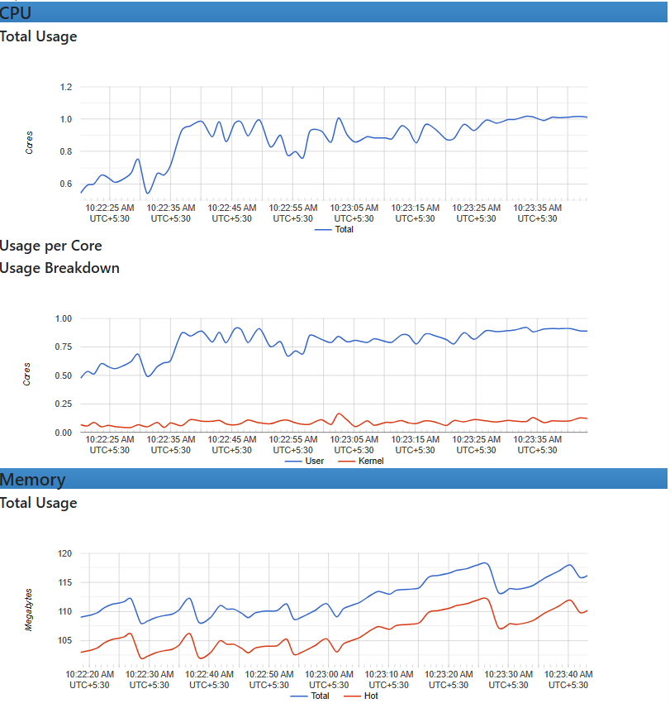

**Container Status**

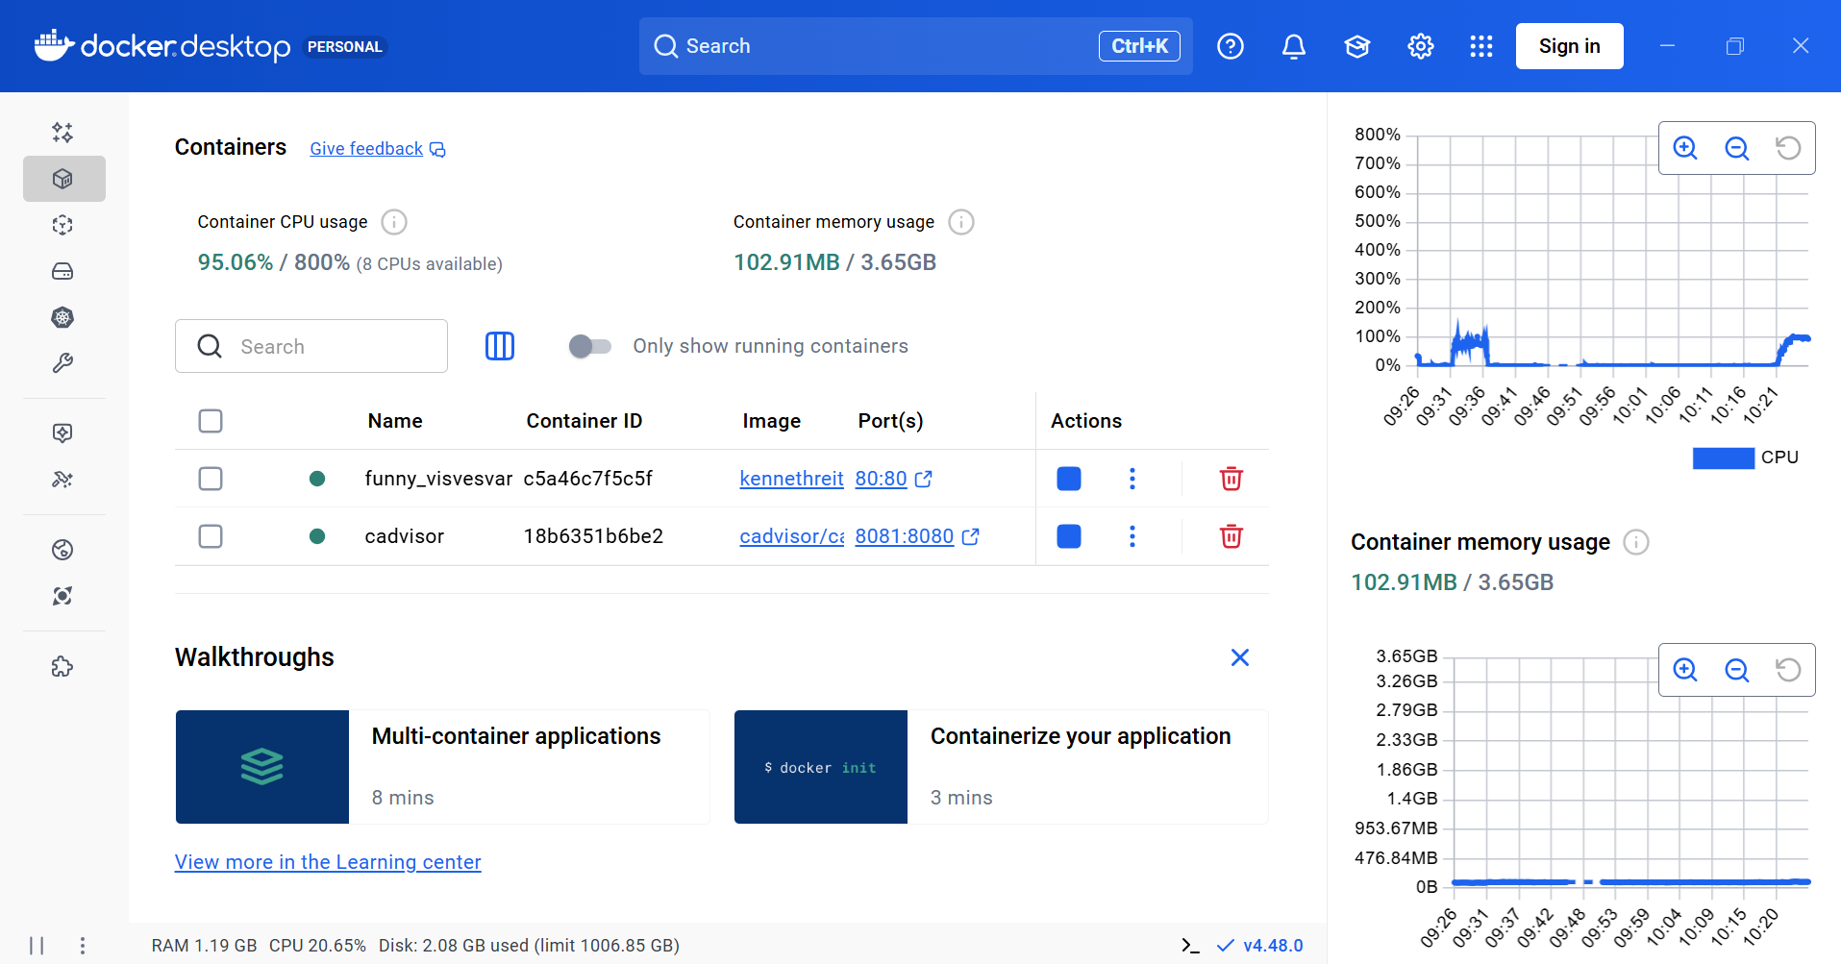

**Verify SLA after execution –**

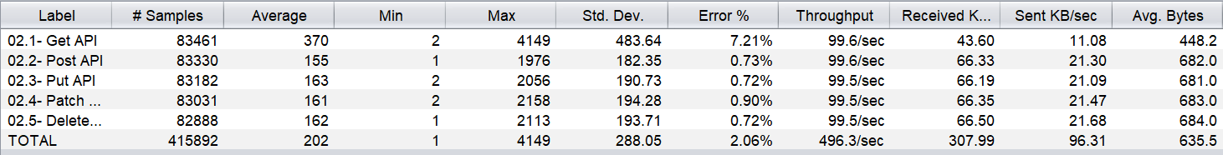

**Verify Infra Status after execution**

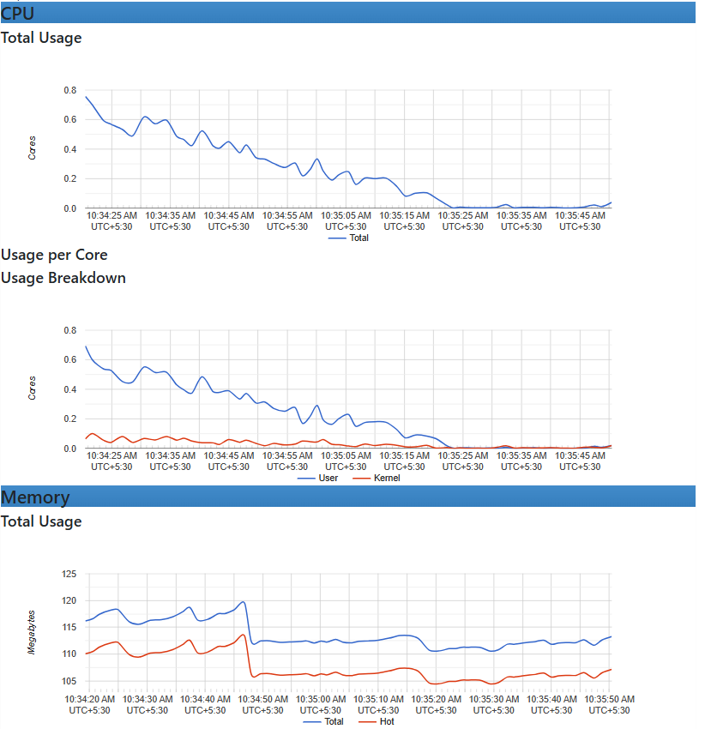

**Summary :**

1. **Response time was high and breaching our SLA**
2. **Throughput Rate also increases**
3. **Error Rate also increased.**

**Spike Test -- 700 users 10 minute duration**

**Configuration –**

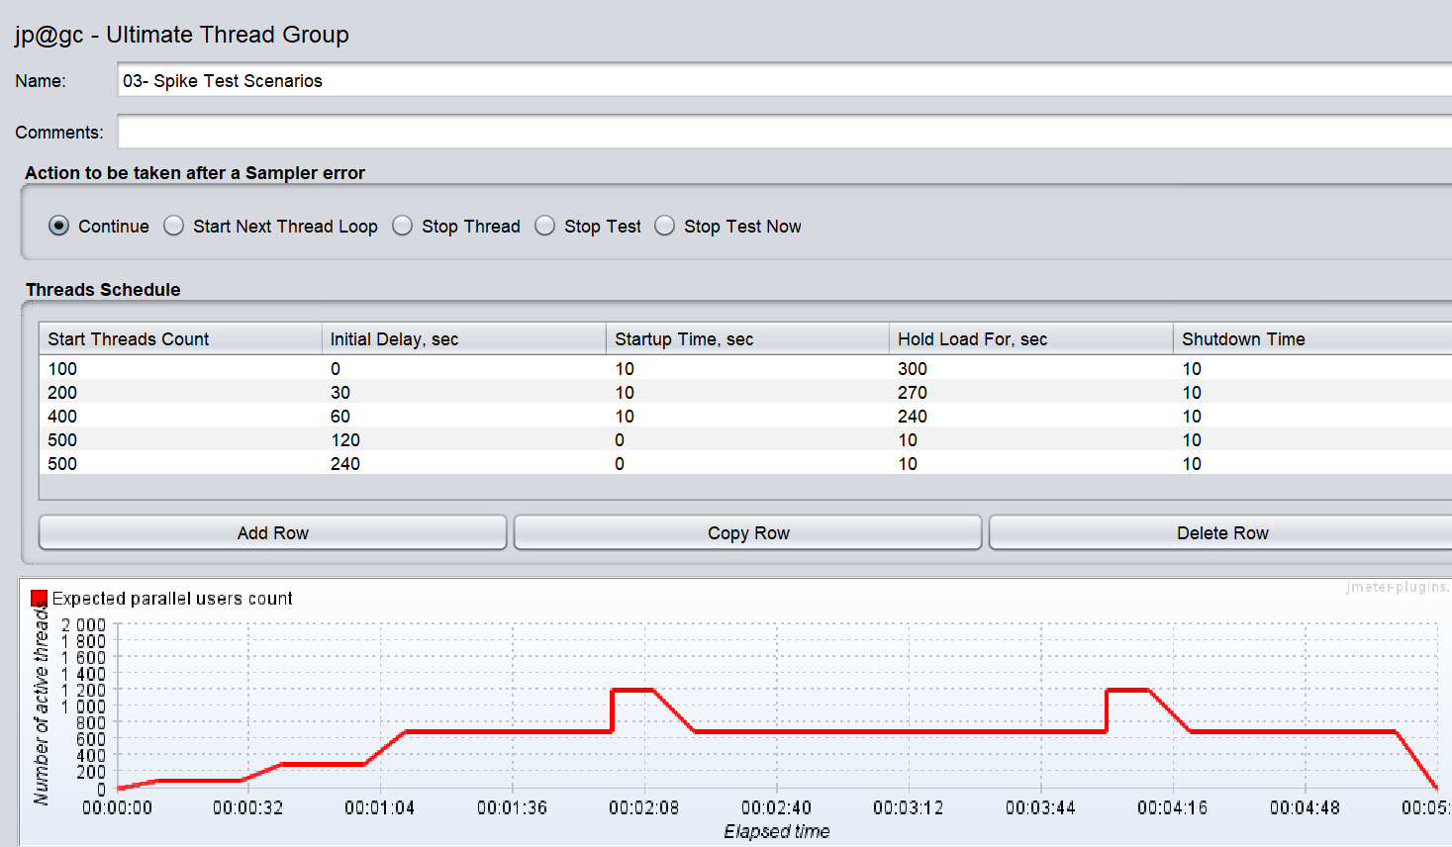

Before execution Infra Status –

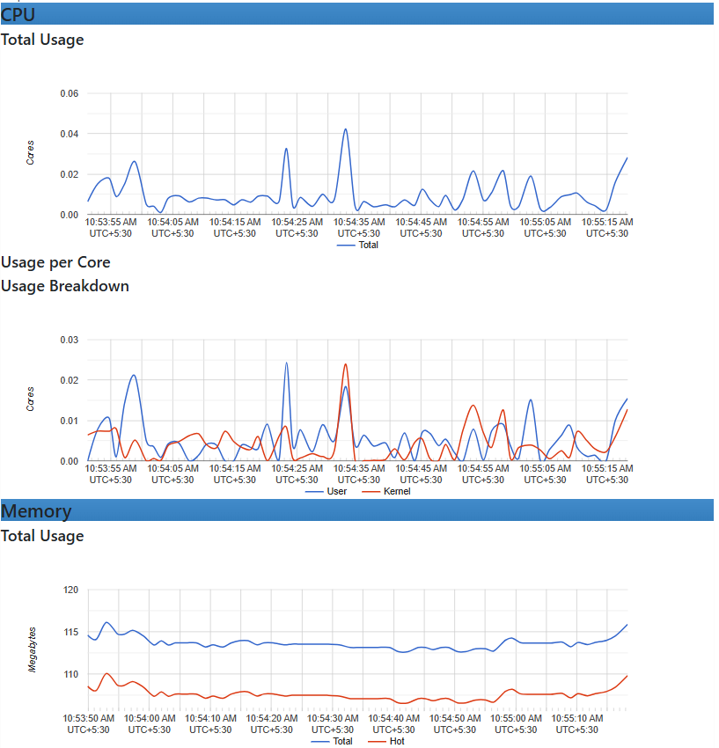

**Verify SLA during test**

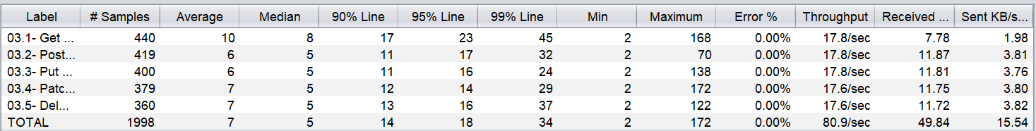

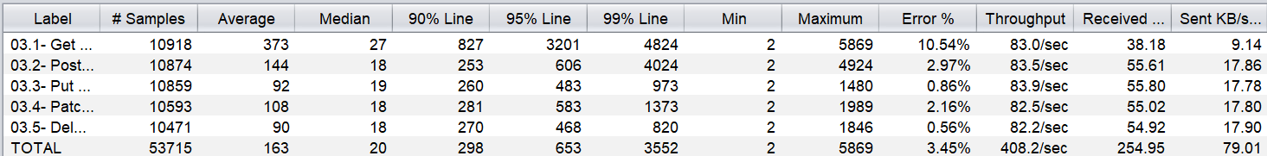

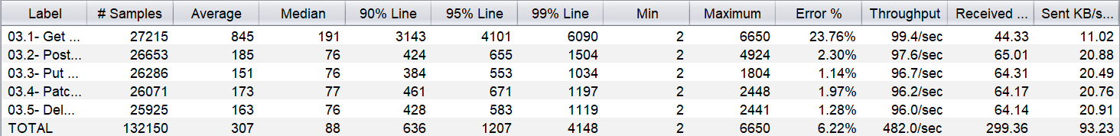

**During test Infra Status–**

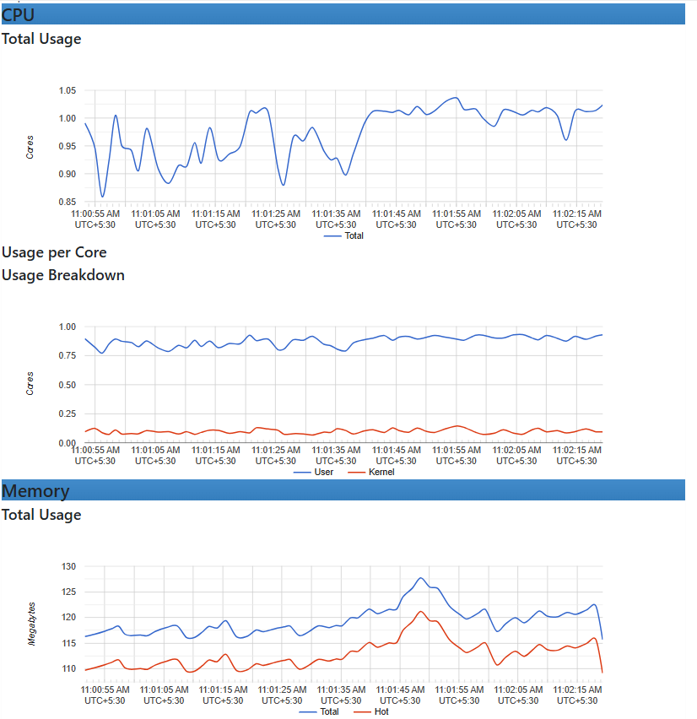

**Container Status**

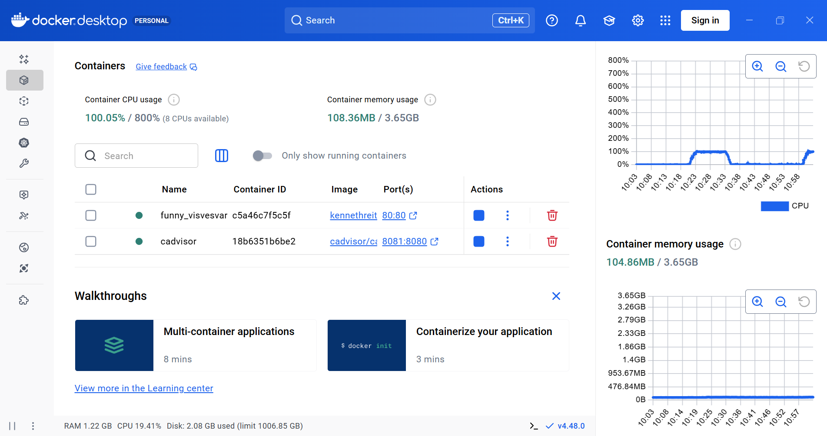

**Verify SLA after execution –**

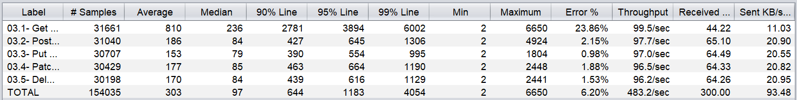

**Verify Infra Status after execution**

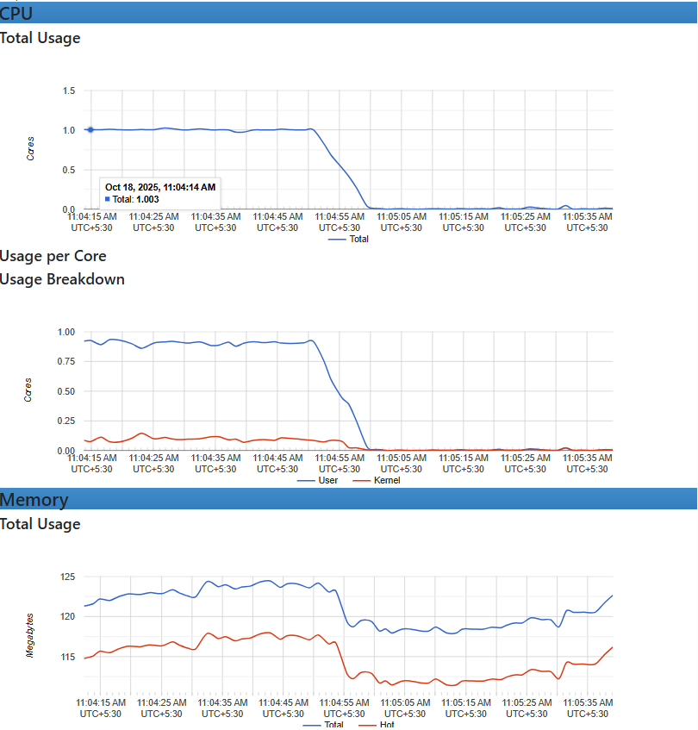

**Summary :**

1. **Response time was high and breaching our SLA**
2. **Throughput Rate also increases**
3. **Error Rate also increased.**

**Endurance Test -- 200 users 1 Hours duration**

**Configuration –**

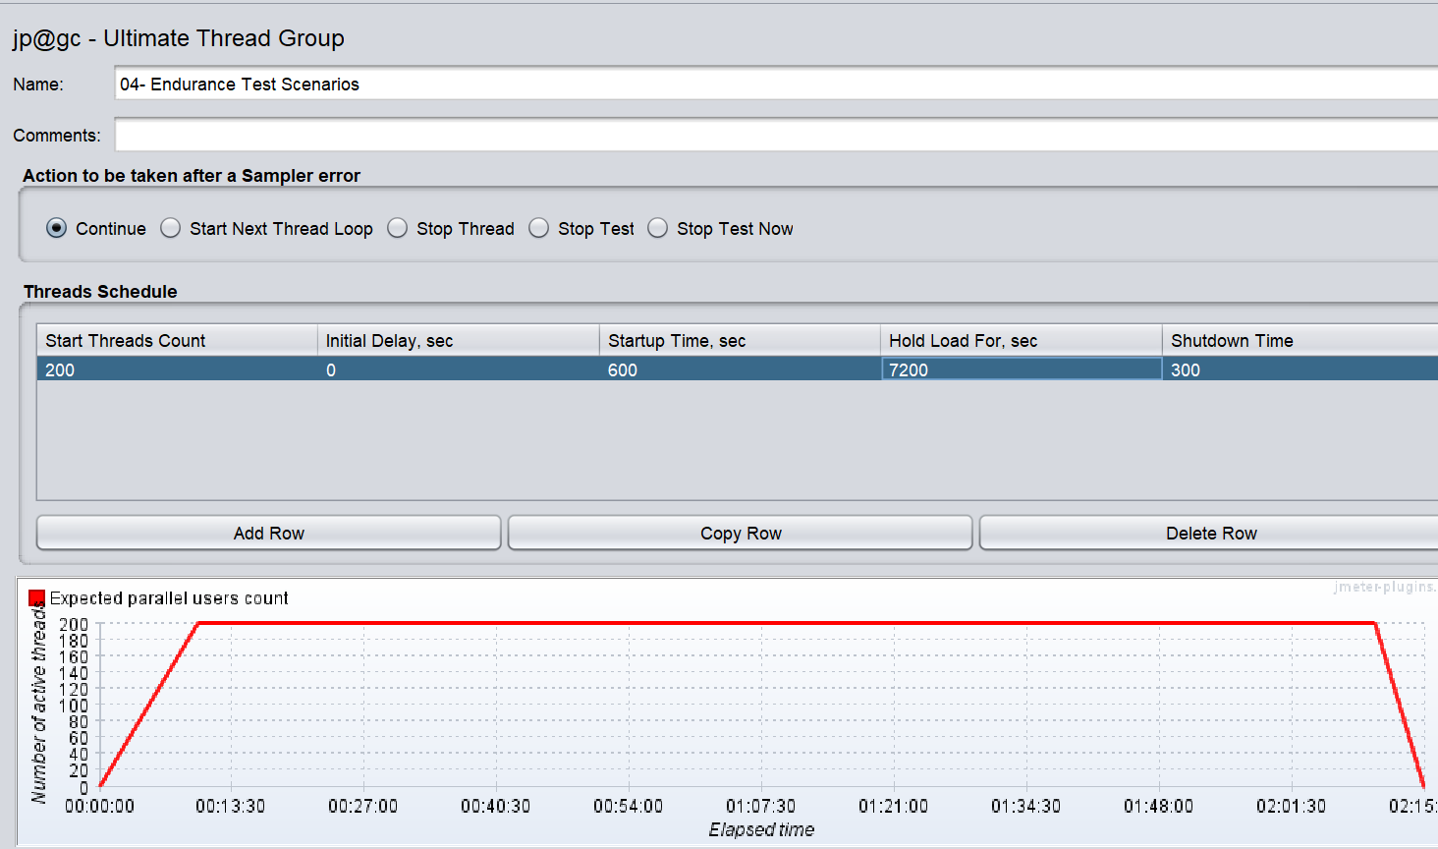

**Before execution Infra Status –**

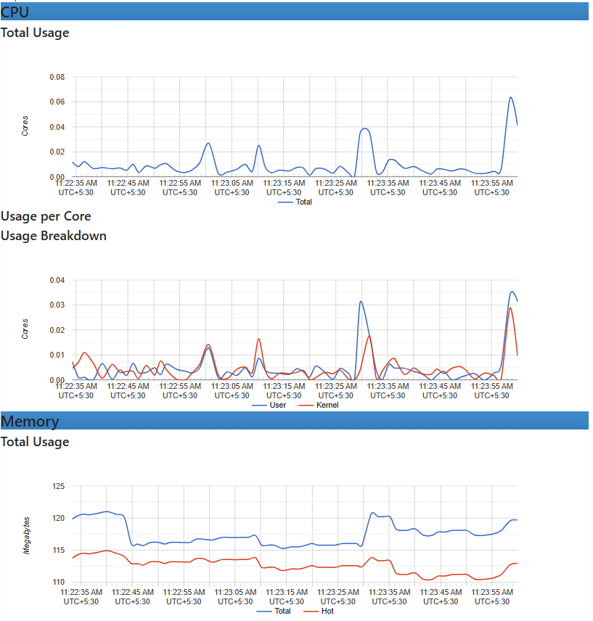

**Verify SLA during test**

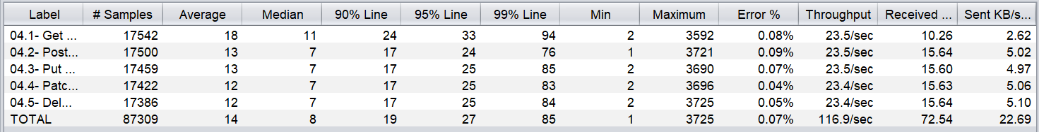

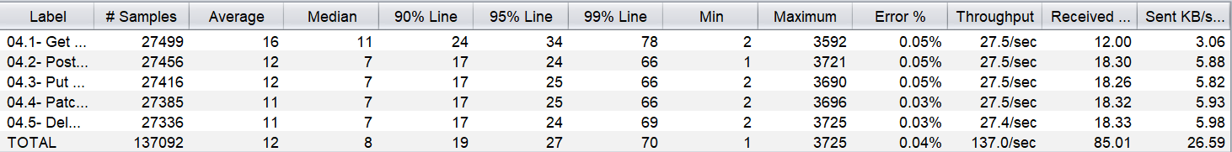

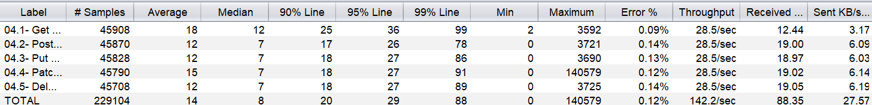

**During test Infra Status–**

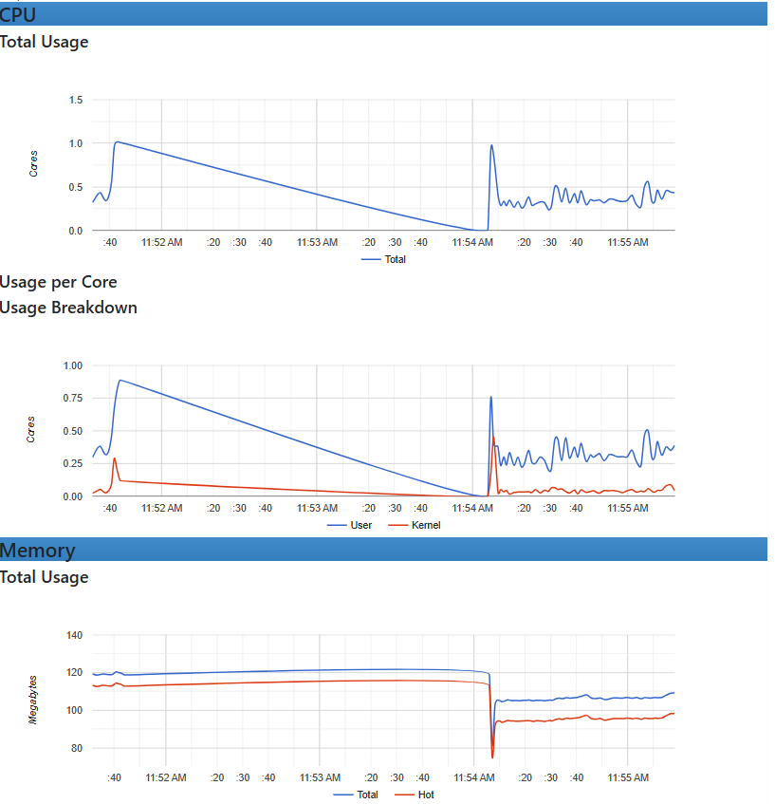

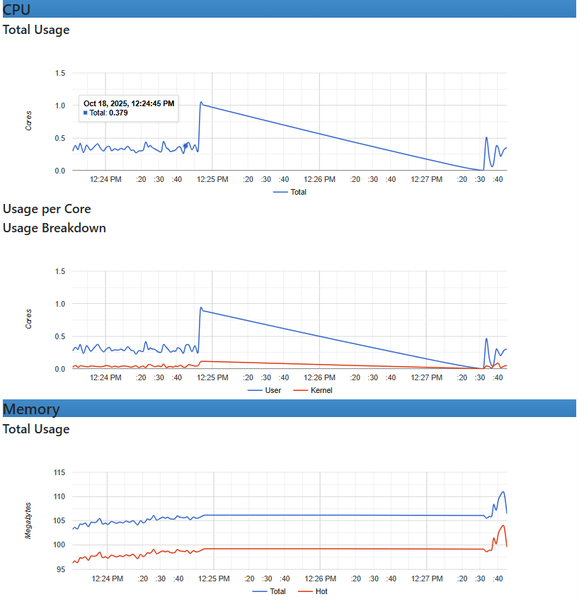

**Container Status**

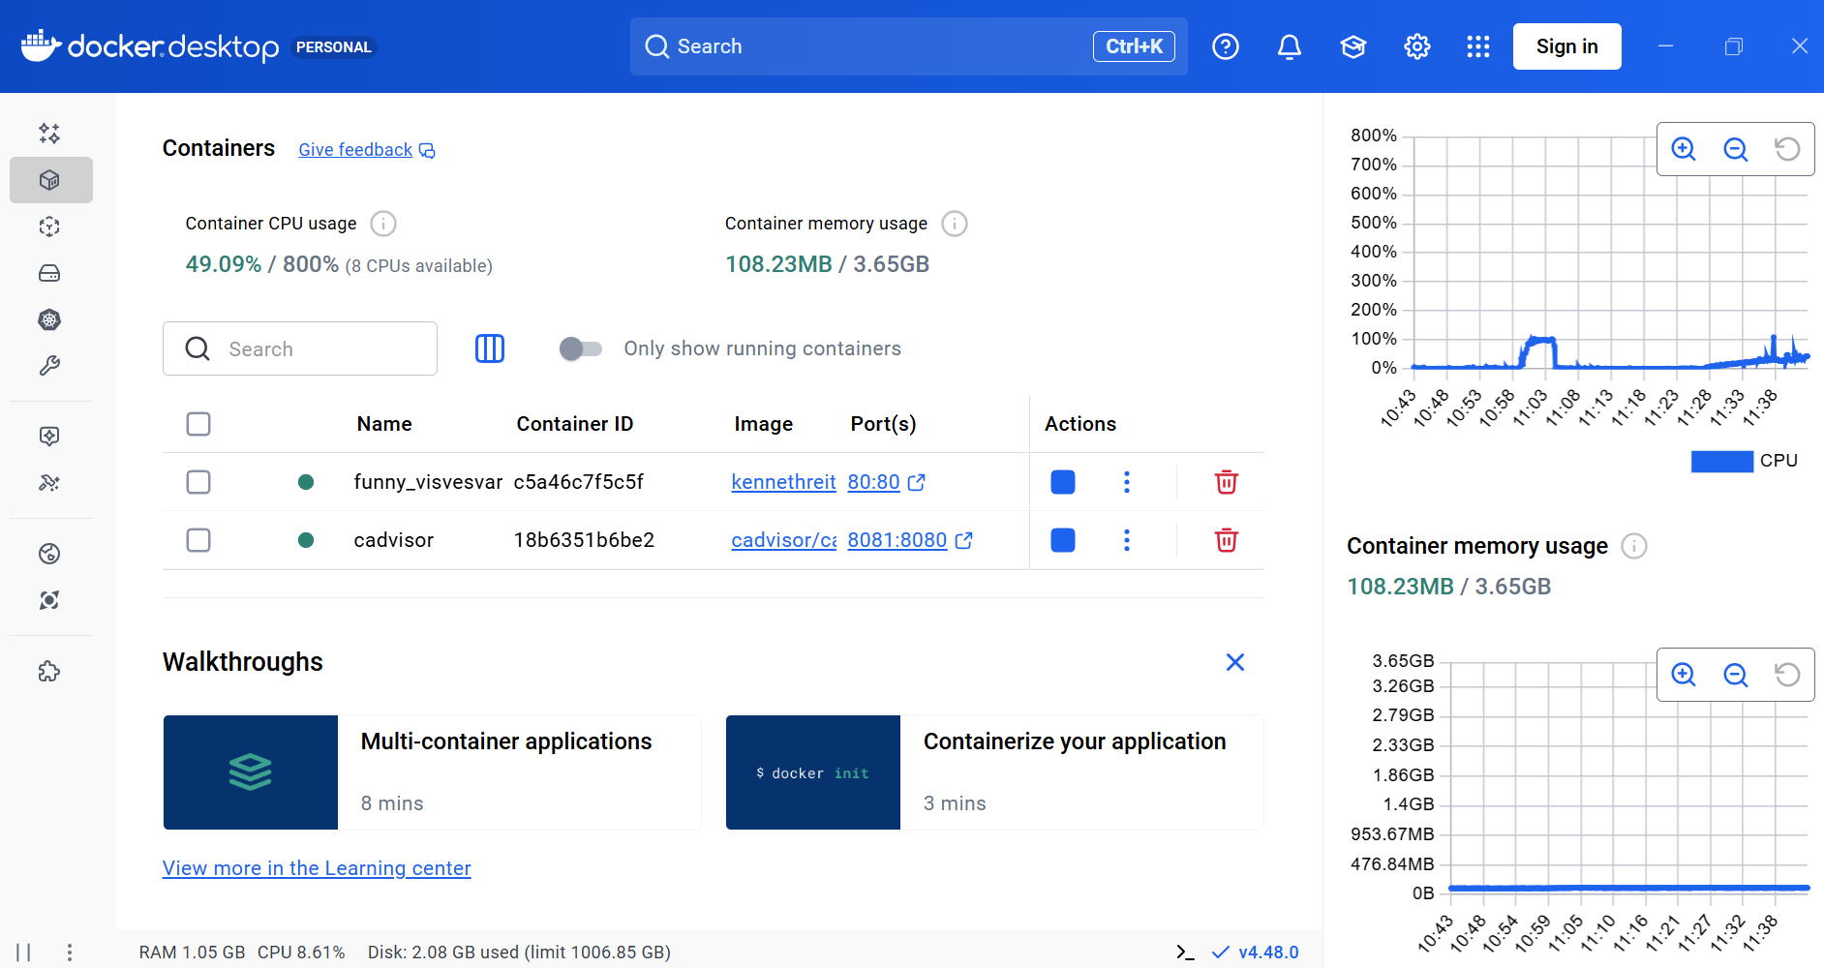

**Verify SLA after execution –**

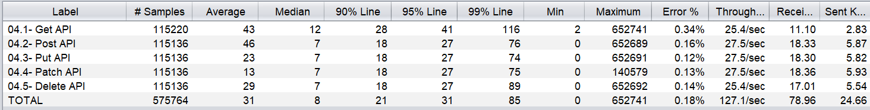

**Verify Infra Status after execution**

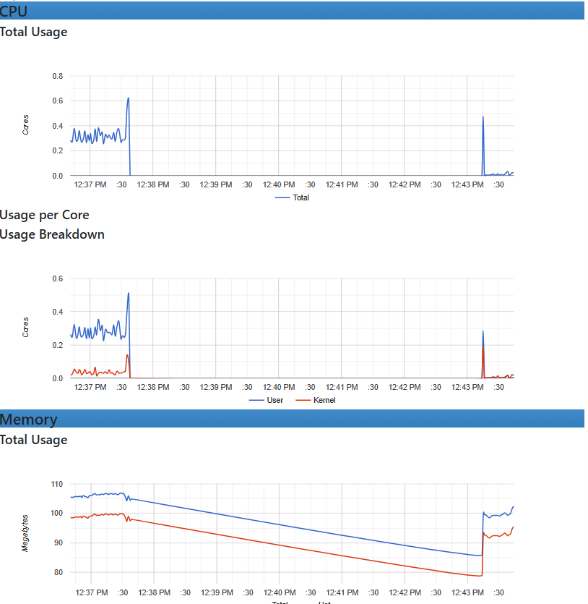

**Summary :**

1. **Response time was high and breaching our SLA**
2. **Throughput Rate also increases**
3. **Error Rate also increased.**

**Test Cycle 2 -**

**Modify Resource** : **As Container CPU usage 2.74% / 800% (8 CPUs available) Container memory usage 73.59MB / 5.65GB**

**Load Test 4.1 -- Warm-up test – 500 users 5 minute duration**

**Configuration –**



**Before execution Infra Status –**

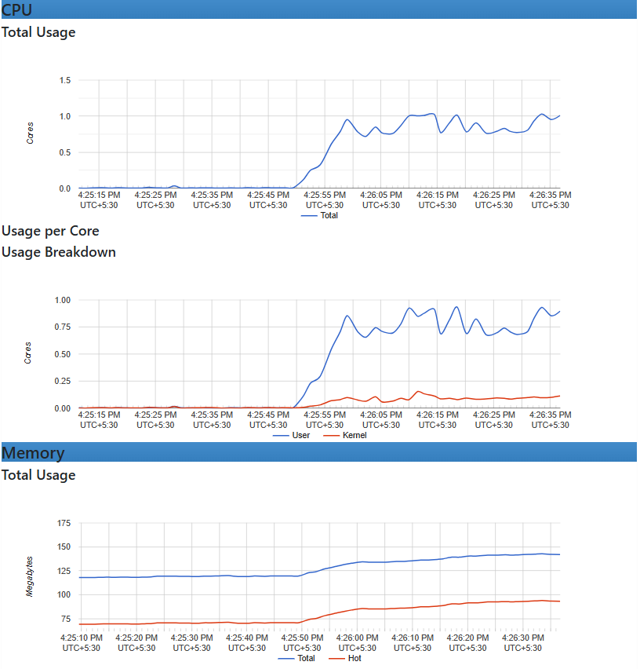

**Verify SLA after execution –**

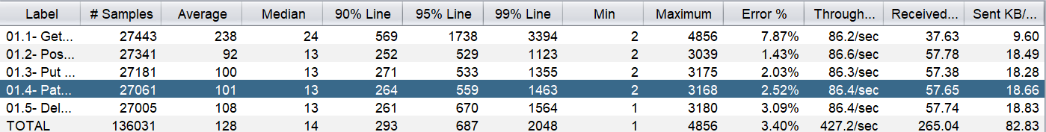

**Summary :**

1. **The response time has improved compared to the previous test.**
2. **However, the throughput rate has slightly decreased.**
3. **The error rate has also reduced, indicating better stability and fewer failed requests.**

**Stress Test 2.1 -- 700 users 10 minute duration**

**Configuration –**

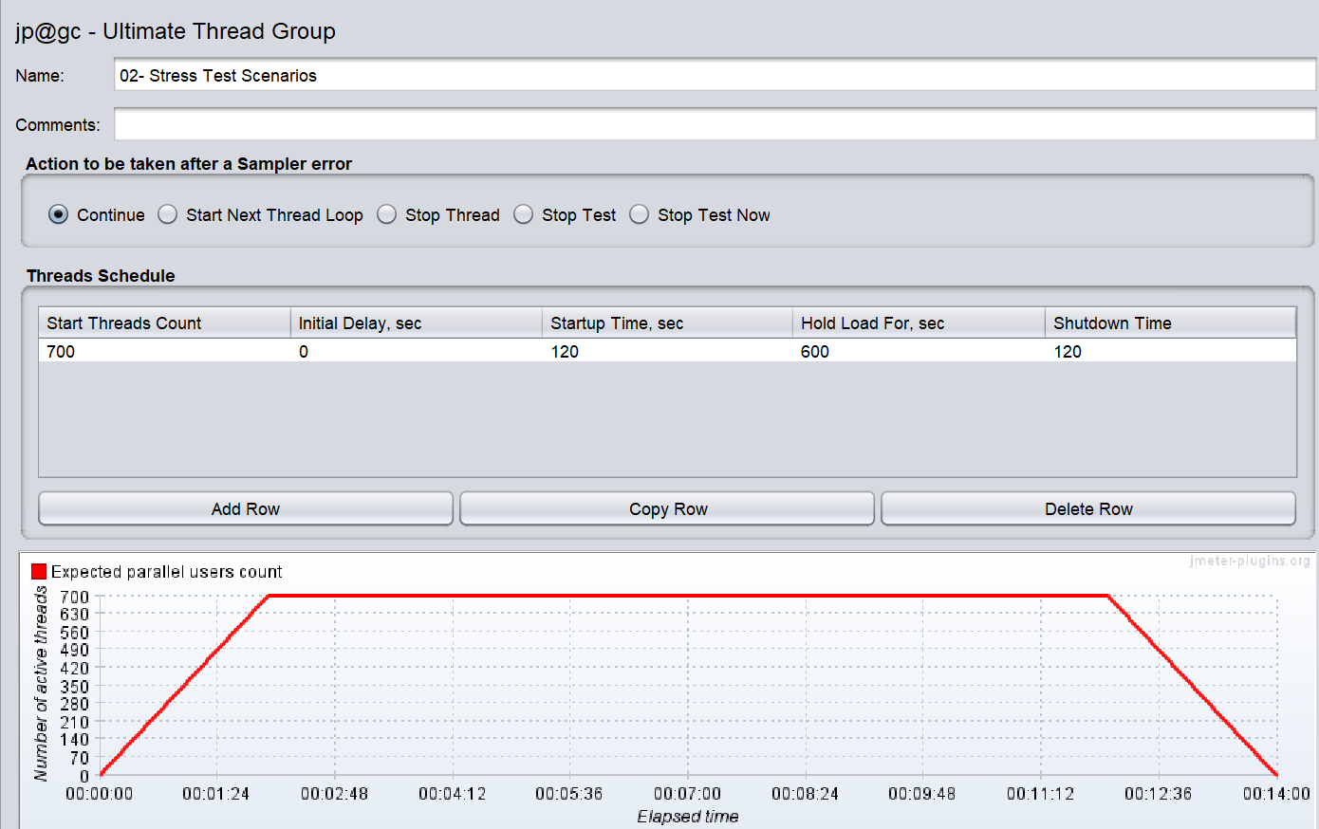

**During execution Infra Status –**

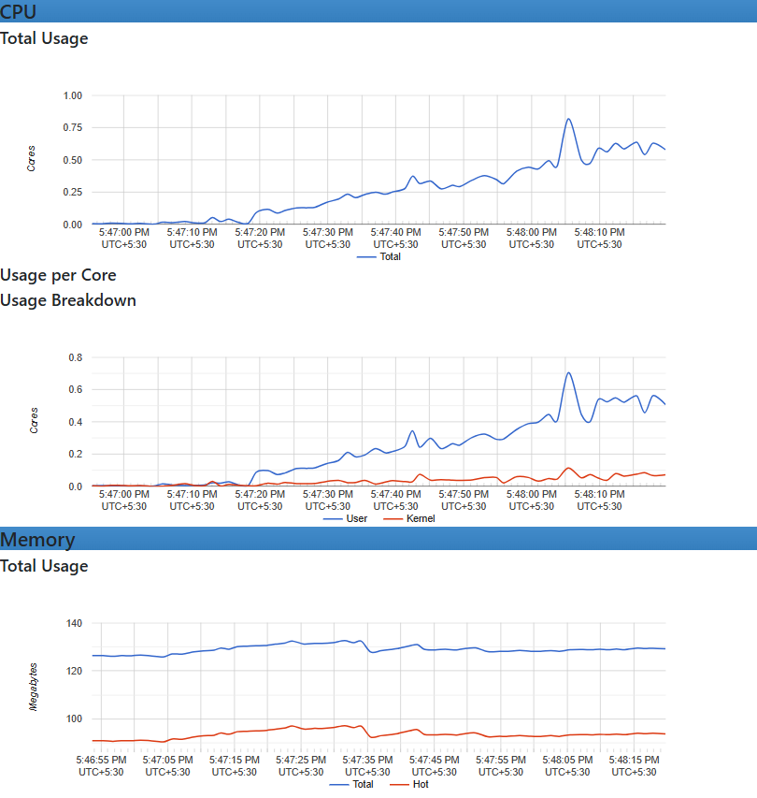

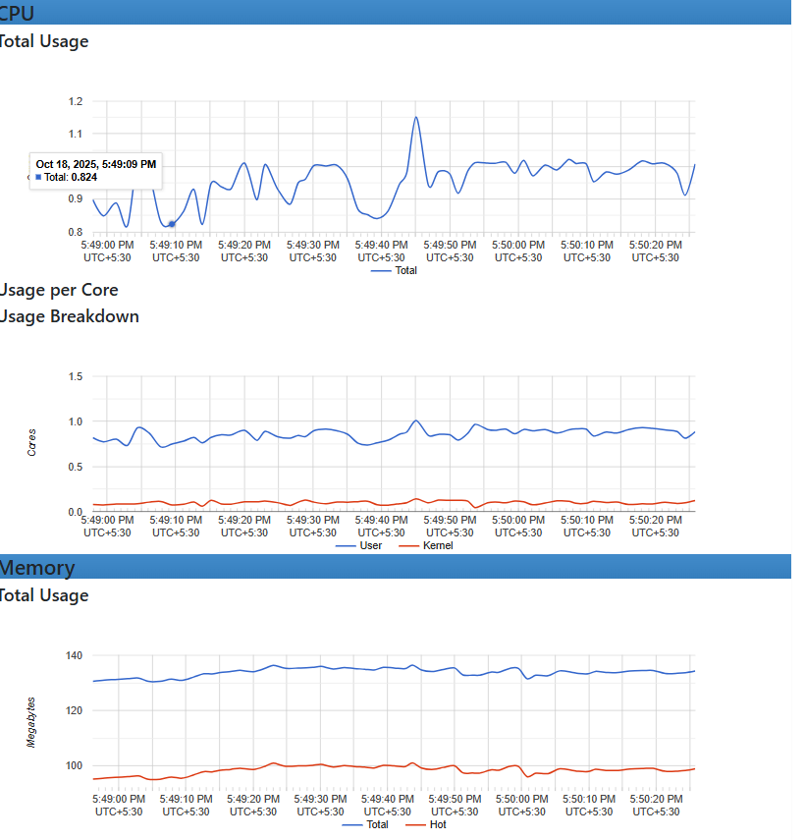

**Verify SLA after execution –**



**Verify Infra Status after execution**

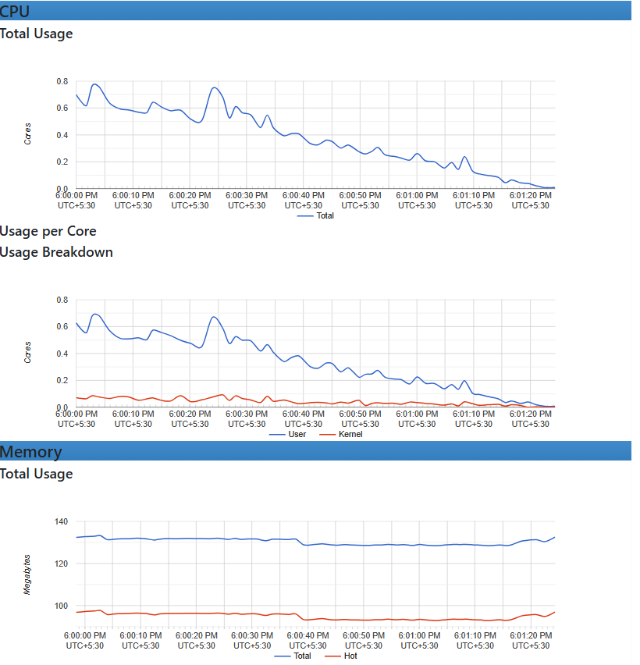

**Summary :**

1. **The response time has improved compared to the previous test.**
2. **90% has also improved.**
3. **However, the throughput rate has slightly increased.**
4. **The error rate has also reduced, indicating better stability and fewer failed requests.**

**Spike Test 3.1 -- 500 users 14 minute duration**

**Configuration –**

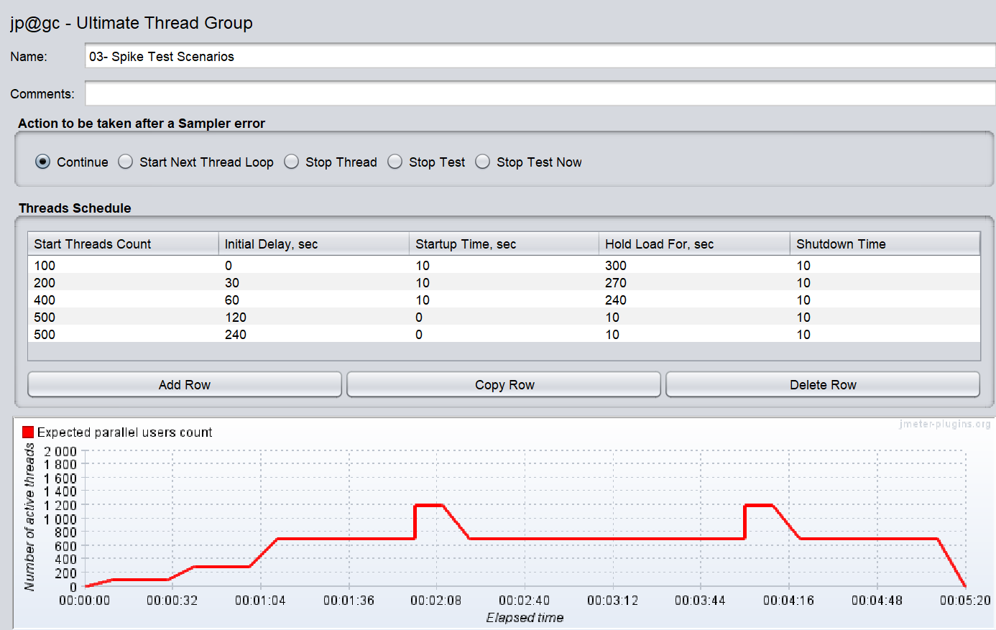

**During execution Infra Status –**

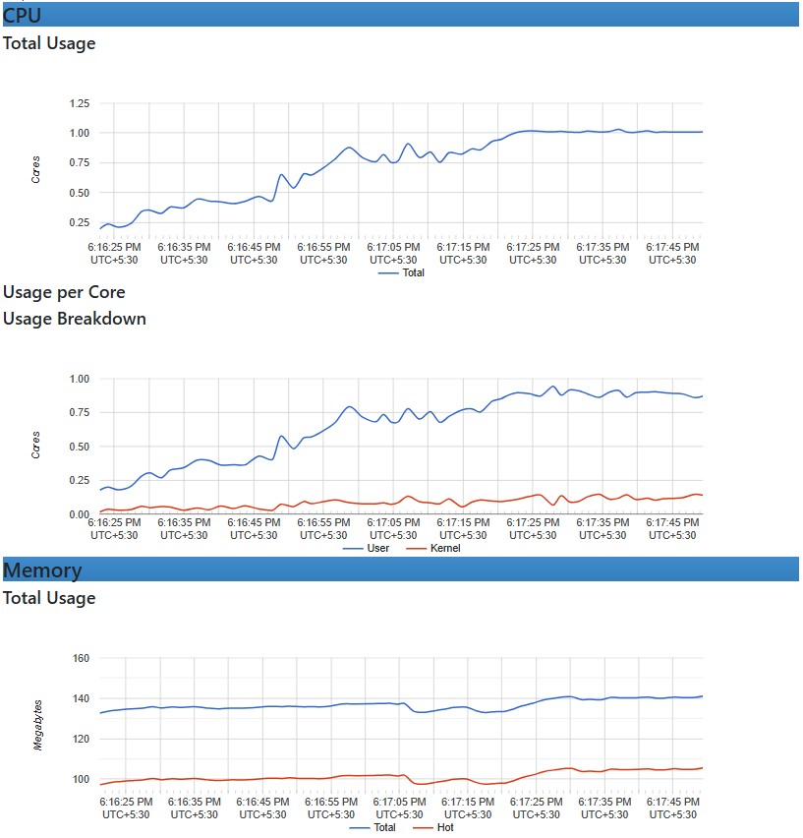

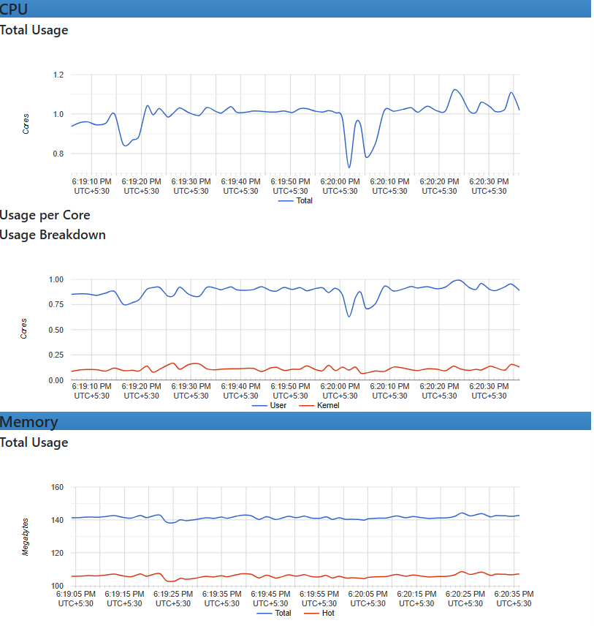

**Verify SLA after execution –**

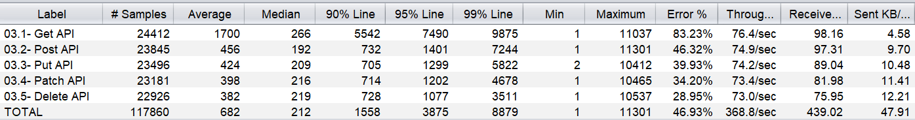

**Verify Infra Status after execution**

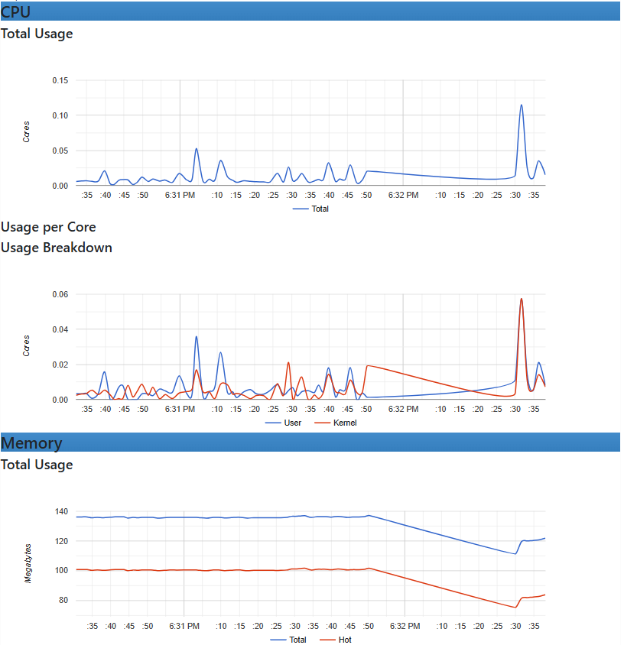

**Summary :**

1. **The response time has improved compared to the previous test.**
2. **90% has also improved.**
3. **However, the throughput rate has slightly increased.**
4. **The error rate has also reduced, indicating better stability and fewer failed requests.**

**Error: Assertion Failed**

**Assertion error: false**

1. **Assertion failure:true**
2. **Assertion failure message:Response time exceeded 1 second for: 03.5- Delete API, actual: 4226 ms**
3. **Assertion error:false**
4. **Assertion failure:true**
5. **Assertion failure message:Error rate above 1%: 100%**

**Endurance Test 4.1 -- 200 users 60 minute duration**

**Configuration –**

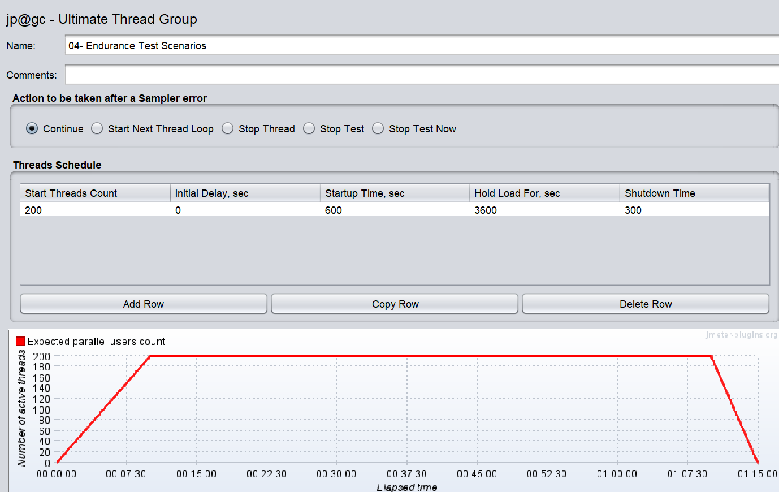

**During execution Infra Status –**

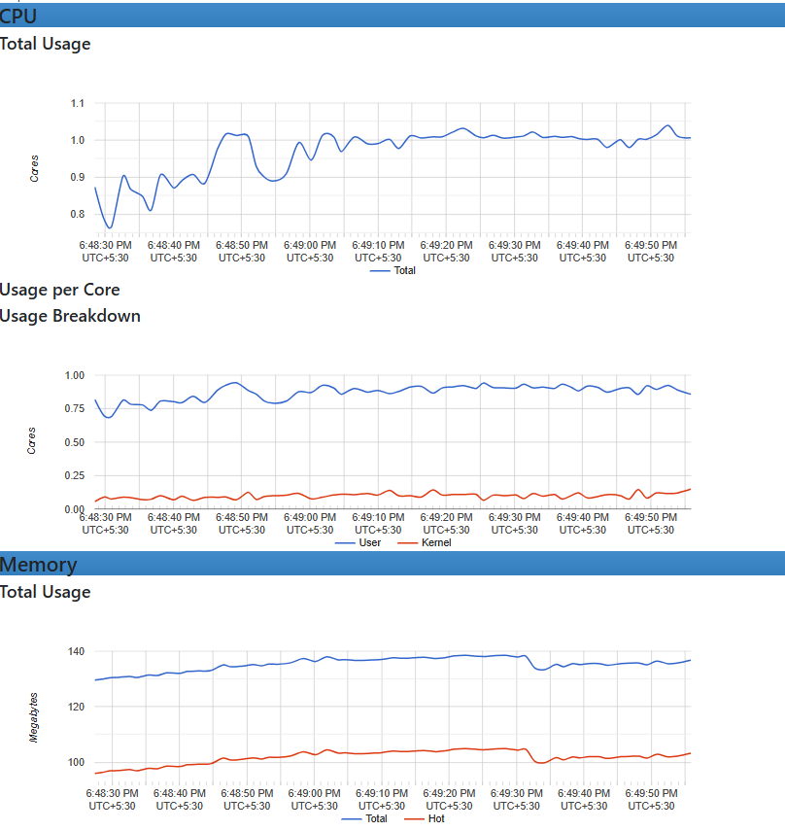

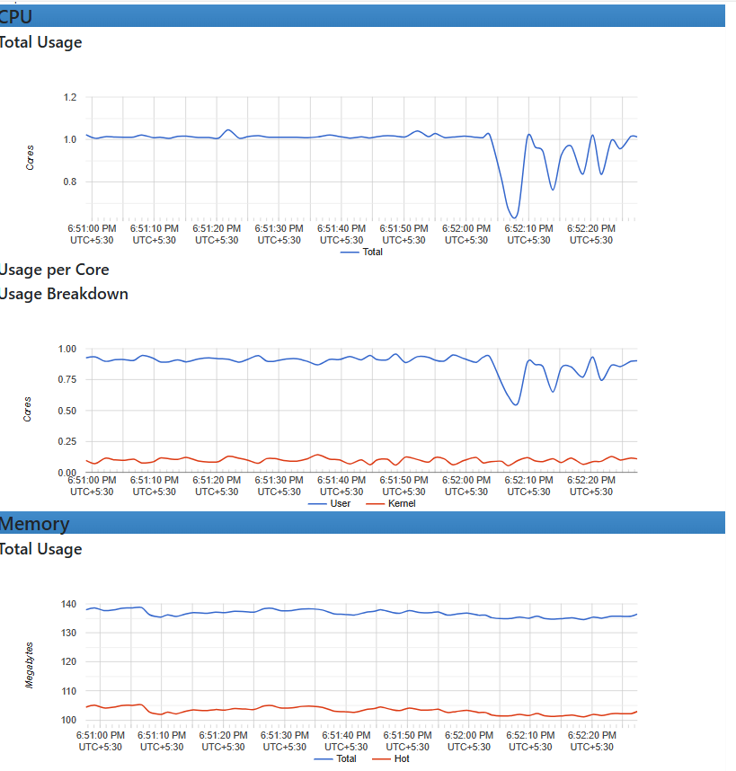

**Verify SLA after execution –**

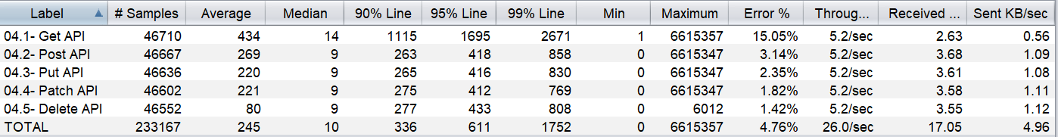

**Summary :**

**Need to do Engineering on this use case (Limited access and tool to diagnose this)**

**Error: Assertion Failed**

1. **Assertion error:false**
2. **Assertion failure:true**
3. **Assertion failure message:Response time exceeded 1 second for: 04.1- Get API, actual: 1052 ms**
4. **Assertion error:false**
5. **Assertion failure:true**
6. **Assertion failure message:Error rate above 1%: 100%**